Good day!
Here are some of the things need to improve/concerns of the users of Verdida Sports Apparel Program as of September 10, 2026.

- Dashboard

Would it be possible make this icon functional? Like the tabs could collapse/appear if this icon will be click/pointed.


- Inventory

- We would like to interchange the version and name of the product. Then, arrange the name alphabetically of that certain version.
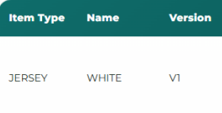

Example:
Version 1 Black will be on top of Version 1 White.
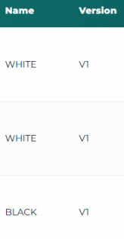

- We would like to simplify the appearance of the inventory especially for the jersey/t-shirts. Instead of displaying all the version and sizes all at once, can we have drop down for the sizes?
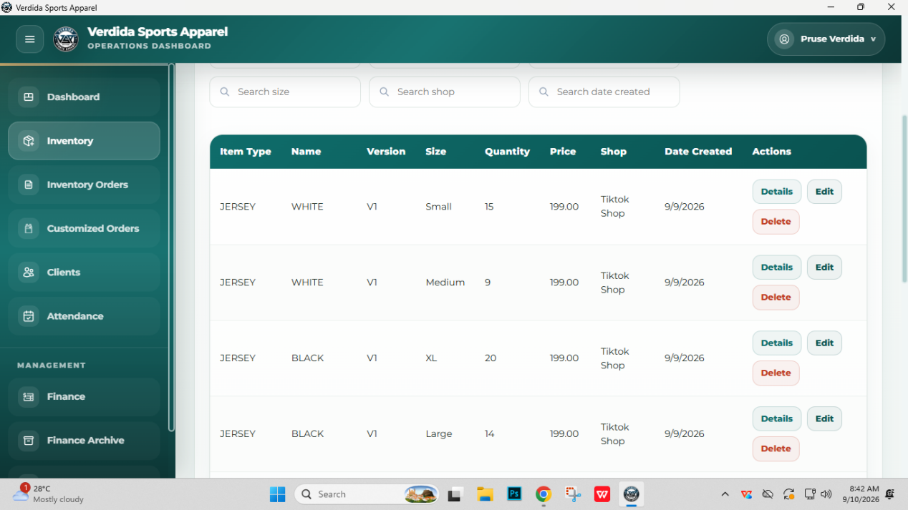

- Here are the sizes that we have (depends on the client’s order): Size 8, Size10, Size 12, Size 14, Size 16, 2XS, XS, Small, Medium, Large, XL, 2XL, 3XL, 4XL, 5XL, 6XL, and 7XL.

- Inventory Orders and Customized Orders

- We cannot seem to add a cancelled items, same with the customized orders.
- We need to have a record for the returned orders with JT Waybill Number/Item number (dapat kami ang mag-encode), Version, Name, Size, Quantity, Price, and Shop details.
- Pick up date should be added each time there is a new order.

- Clients

Whenever we register a client, can we also include the following:
- Company/School
- City/Municipality
- And the list of orders that this client has been placed (connected to the encoded orders)

- Attendance

- Even if the date has been automated, can we still have the option to change it whenever we add a new attendance? We have seen an option below once the attendance has already been registered but it would be a big help if this portion have that option too.

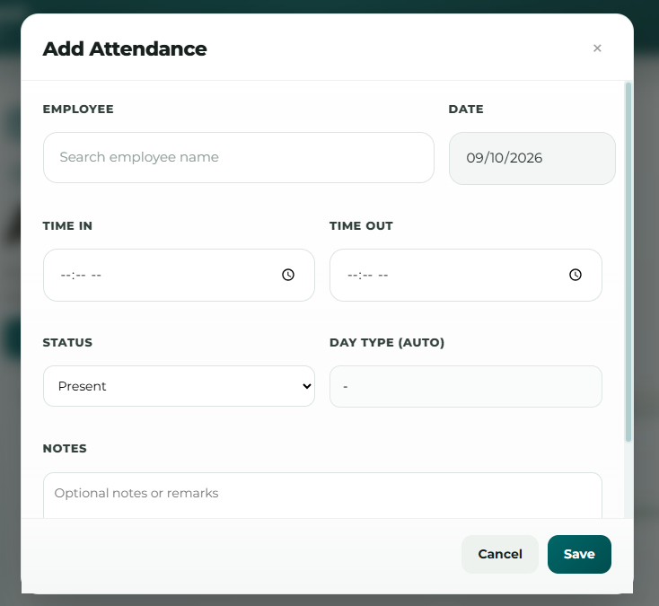

- Please add an undertime in the day type.
- Also add another table for time in and out. There should be an in and out in for morning and time in and out for the afternoon.

- Employees

- Please add the Graphic Artists, Sales, Machine Operators on the Team.
- We cannot register an employee and admin as of the moment. There is an error.

- Finance

We cannot fully explore the finance as of the moment because we cannot cancel an order too.
Additional:
Please add a back button (linked from the previous tab that was opened).

